**Honda Performance Report**

Table of Contents

1.0 Introduction to the Problematic Situation/Opportunity 3

2.0 Theoretical Frameworks to Connect the Problem/Opportunity 4

2.1 Porter's Five Forces Model 4

2.2 Kano Model of Customer Satisfaction 5

2.3 Price Optimization Models 6

3.0 Critical Analysis and Justification of the Dashboard Solution 6

4.0 Conclusion and Recommendations for Implementing the Business Intelligence/Analytics System 10

References 12

# 1.0 Introduction to the Problematic Situation/Opportunity

Honda, as one of the leading automobile manufacturers globally, faces numerous challenges and opportunities in an increasingly competitive market (Honda Engines, 2016). Despite its strong brand reputation for producing reliable, fuel-efficient vehicles, the company must navigate complex dynamics around customer satisfaction, pricing strategies, and regional sales distribution. The automotive market is evolving rapidly, influenced by shifting consumer preferences, technological advancements, and economic fluctuations. The market share, sales growth, and customer loyalty can considerably be enhanced by Honda through leveraging data-driven insights. The first key challenge for Honda relates to optimizing its pricing strategy in the used and certified pre-owned vehicles. Used car sales are a significant component of the automobile market; however, Honda's pricing approach has been inconsistent, thereby warranting potential inefficiencies. The data shows that some model high-mileage vehicles are still priced higher, a fact that may puzzle consumers or dilute the value proposition of the brand. More importantly, from the dashboard, this report shows that used cars, for example, Ridgeline RTL-E tend to have relatively lower customer satisfaction ratings compared with Honda Certified and new models. This means that Honda's used vehicle division may have to better its offer in terms of quality assurance, customer support, and marketing (Kopanakis et al., 2016).

Another major area of opportunity is uncovering and increasing Honda's sales coverage across different states and seller types (Honda World, 2016). The analysis shows a dominance of dealer sales in the market. However, there are various regions, such as Delaware, showing low sales figures for the business, which may be indications either of saturation in the market or a lack of dealership presence. Here, individual sales might be a lucrative growth opportunity for Honda, but only if data is utilized to hit such unserved areas with specific marketing actions. Customer satisfaction, most specifically for various models of Honda and for their new, used, and Honda Certified conditions, is a continuing challenge. Consumer rating insights reveal that not all models have the same level of satisfaction. Some are higher in satisfaction ratings, such as the CR-V EX-L, while some receive lower rates, like the Ridgeline. Closing these gaps will help improve Honda's reputation in totality and encourage customers to remain loyal. Implementing a fully-fledged business intelligence and analytics system could help Honda tailor its sales, pricing, and customer service strategies to maximize competitiveness in the market (Kaplan & Norton, 1996).

# 2.0 Theoretical Frameworks to Connect the Problem/Opportunity

To understand the problematic situation and opportunities that Honda goes through regarding its sales, customer satisfaction, pricing strategies, and market performance, one requires using relevant theoretical frameworks. These frameworks will provide a structured approach to analyzing issues, and consequently their solutions in facing the challenges that Honda is encountering. The most relevant theoretical frameworks to apply to Honda's case are Porter's Five Forces, the Kano Model of Customer Satisfaction, and Price Optimization Models.

## 2.1 Porter's Five Forces Model

The Porter's Five Forces model remains a valuable analytical tool in examining the industry's competitive environment and understanding how different external factors impact the chances of profitability for an enterprise (Tower, 2015) . The five forces are:

**Threat of New Entrants:** The automobile industry is capital-intensive, involving significant investment in manufacturing, distribution networks, and brand development. It is relatively difficult to enter this industry therefore, which limits new entrants' threat. However, companies like Tesla have shown that disruptive innovations in EVs can form new competition, especially for the established brands like Honda. Thus, this external threat mandates Honda's continued investment in innovation as well as customer loyalty, both of which are reflected in the urgency of seeking better customer satisfaction and competitive pricing strategy (Kaplan & Norton, 1992).

**Bargaining Power of Suppliers:** Honda uses several suppliers for raw materials, parts, and technology that are major cost contributors to the company. However, Honda's size and global reach also confer great bargaining power over suppliers. Rising demand for electric and hybrid vehicles increases pressure on suppliers, who have to cope with new technological requirements. Honda's price-increasing and reducing the selling expenses will depend on its management of relationships with suppliers and also how it integrates new technologies with vehicle offerings (Slater & Olsen, 2002) .

**Bargaining Power of Buyers**: Automotive markets are highly competitive, and more and more well-informed customers; therefore, buyer bargaining power is high. The data of consumer ratings related to dashboards point out how buyer satisfaction constitutes an important element of the competitive advantage of Honda. Consumers now pay much more attention to features such as reliability, performance, and pricing. Therefore, Honda needs to monitor consumer feedback, customer satisfaction, and price sensitivity. In the context of used cars, buyers may be even more price-sensitive and cautious (Simoes, 2013) .

**Threat of Substitutes**: The threat of substitutes in the automotive industry arises from alternative transportation options, including public transportation, ride-sharing services (Uber, Lyft), and electric bicycles. Honda should take advantage of the increasing demand for electric vehicles. This is one means to reduce the propensity for substitute threat. The increased need to embrace sustainable solutions calls for improvement not just in conventional combustion engines but also in electric power offerings for Honda to keep its position ahead (Hashmi, 2015).

**Industry Rivalry:** The auto industry is a highly competitive industry. Honda also faces stiff competition from traditional Brands like Toyota, Ford, and General Motors as well as new entrants such as Tesla. The competitions in both the new and used vehicle markets are very strong, and pricing, reliability, and consumer satisfaction appear to be the prime drivers of competitive advantage. Honda's potential to differentiate itself in these aspects will determine market share and profitability. The data from the customer satisfaction and pricing strategy dashboard can aid Honda in making a better judgment regarding where it stands in comparison to its competitors and areas needing improvement (Recklies, 2015) .

As applied Porter's Five Forces to Honda, one can reveal a great deal of work on maintaining a competitive price while improving customer satisfaction as well as adapting to the changing consumer preference. The real challenge lies in balancing all these forces by harnessing opportunities for innovation - such as electric vehicles - before the emerging competition better satisfies consumer needs.

## 2.2 Kano Model of Customer Satisfaction

The Kano Model helps to identify customer satisfaction factors by segmenting product features into five categories; Basic Needs, Performance Needs, Excitement Needs, Indifferent Needs, and Reverse Needs.

**Basic Needs:** These are the essential expectations of the customers, such as reliability and safety. Honda is solid in these areas, since models like the CR-V EX-L and Pilot Sport boast high ratings from customers.

**Performance Needs:** In this category falls fuel efficiency, price, and design. Honda needs to work on its used car price and provide competitive options in electric vehicles.

**Excitement Needs:** Unexpected features that bring joy and amaze the consumer. Honda can differentiate itself from competition by introducing innovative features in their vehicles such as advanced technology or sustainable materials (Gross et al., 2014).

Honda can use the Kano Model to formulate its product development and customer satisfaction strategies so that it delivers basic customer expectation but surpasses in respect of performance and excitement factors. This would help Honda to improve customer satisfaction and that too mainly in case of used cars market where Honda faces stiff competitions.

## 2.3 Price Optimization Models

With such dashboard data on the used car, "Mileage vs. Price," price optimization models can turn out to be very useful for Honda. They enable companies to set dynamic prices that maximize profit yet remain competitive. For Honda, using the price elasticity models whereby a car's price varies with its demand and the market to which it is sold can optimize both the selling price of new and used vehicles. This may explain the anomalies in the "Mileage vs. Price" scatter plot, where high-mileage vehicles were still fetching higher prices.

# 3.0 Critical Analysis and Justification of the Dashboard Solution

Below is the Honda Sales and Performance Insights Dashboard, which summarizes key performance metrics and customer insights. Using sales distribution and consumer ratings, vehicle pricing, and reliability in analyzing the data, the dashboard allows Honda to understand what areas are strong and weak and opportunities that have been realized or otherwise. Based on the aforementioned potentials and room for improvement at Honda, this section critically examines the relevance and impact of the business intelligence solution herein proposed-that is, the Honda Sales and Performance Insights Dashboard.

**Rationale for Dashboard Solution**

The dashboard solution will prove highly effective in addressing the business intelligence needs of Honda. It will integrate information coming from different business lines—sales, ratings by customers, pricing, and vehicle performance—into a single view that is visually accessible. This way, Honda can easily figure out patterns, trends, and anomalies that call for attention. The dashboard will supply actionable insights for strategic decisions, such as optimizing sales channels, improving customer satisfaction, and finding means of refining pricing strategies.

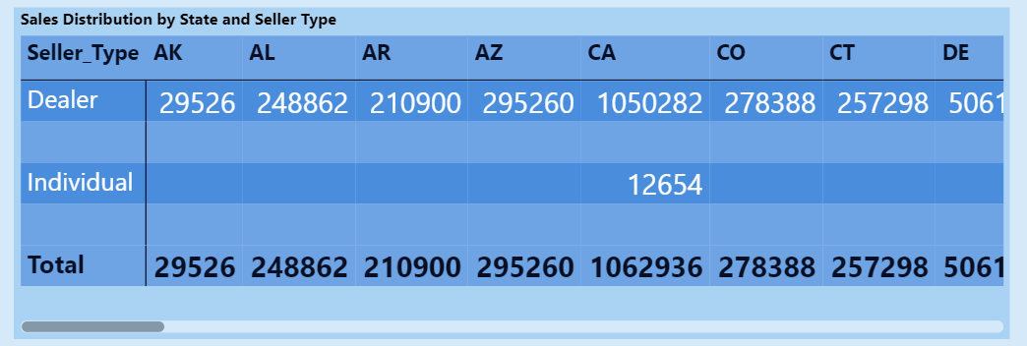

**1. Sales Distribution by State and Seller Type**

* **Objective**:
  + This table highlights the total sales distribution across states and seller types (Dealer vs. Individual).
  + **Insights**:
    - Dealers dominate the sales across all states, with states like **AZ** and **CO** showing the highest dealer sales.
    - Individual sales are significantly lower, suggesting that most vehicles are sold through authorized dealerships.
    - States with fewer sales (e.g., **DE**) could indicate lower market demand or a lack of dealership presence, presenting opportunities for targeted marketing or dealership expansion.

This insight is critical for Honda to make strategic decisions in terms of market expansion and resource allocation. States with lower sales figures, such as DE, may signify an underpresence of dealers or lower market demand. The dashboard allows Honda to identify areas it needs to fill in by targeting poor regions through strategic marketing campaigns or dealership expansion (Graeme and Nargiza, 2012).

**2. Top 10 Average Consumer Rating Analysis**

* **Objective**:
  + This bar chart shows the average consumer ratings for the top 10 Honda models, segmented by condition (Honda Certified, New, Used).
  + **Insights**:
    - **CR-V EX-L** and **Pilot Sport** models have the highest ratings, particularly for Honda Certified vehicles, indicating high customer satisfaction.
    - Lower ratings for used vehicles (e.g., **Ridgeline RTL-E**) highlight potential areas for improving quality control or customer support for used cars.
    - Promoting Honda Certified vehicles with high ratings can drive consumer trust and boost sales.

This feature in the dashboard lists the average consumer rating of the Honda models. It encompasses rating by segmentation of vehicle condition as well: Honda Certified, New, Used. For instance, it shows that CR-V EX-L and Pilot Sport receive higher ratings; mostly in certified pre-owned category, as customers would love to own a Honda Certified model due to assured reliability and quality (Cadle et al., 2014).

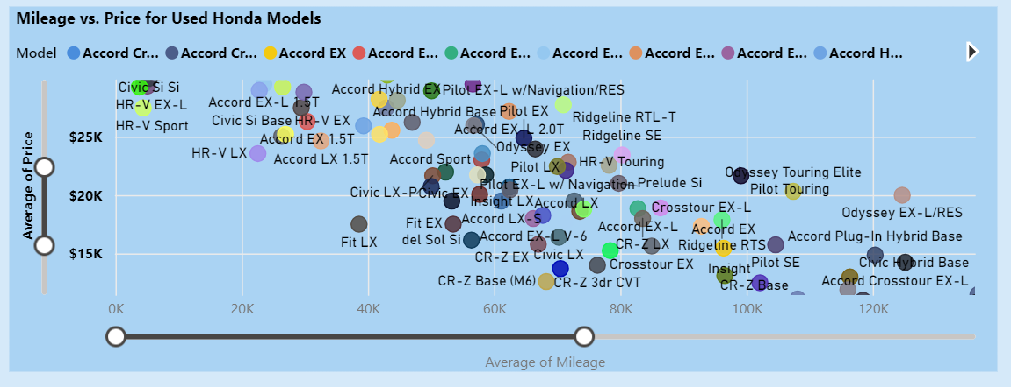

**3. Mileage vs. Price for Used Honda Models**

* **Objective**:
  + This scatter plot analyzes how mileage impacts the price of used Honda vehicles across different models.
  + **Insights**:
    - Models like the **CR-V EX-L** retain their value better even at higher mileage, making them attractive to budget-conscious buyers.
    - There’s a clear negative correlation between mileage and price, but some anomalies exist where high-mileage vehicles still command higher prices (potentially due to added features or better condition).
    - This analysis helps identify models that can be marketed as "value retainers," like the CR-V lineup.

A very important scatter plot is the "Mileage vs. Price". It reflects an analysis of how the mileage of vehicles impacts the price of a used car. While there's expected to be negative correlation in this relationship-the value of a used car will likely decrease with high mileage-the plot does show some outliers where vehicles with high mileage still have above-average prices (David & Graeme, 2015).

**4. Reliability and Performance Ratings**

* **Objective**:
  + This bar chart compares the average scores for reliability, performance, and comfort for different Honda models.
  + **Insights**:
    - Models like **Pilot Sport** and **Passport TrailSport** show strong performance in all three categories, making them attractive for family buyers or long-distance travelers.
    - Lower comfort ratings for models like **Civic Type R** highlight areas where improvements can be made.
    - Marketing campaigns can emphasize models with balanced strengths across all attributes, such as **CR-V Hybrid Sport**.

The reliability and performance ratings section of the dashboard captures how respective Honda models relate in terms of even three key categories- reliability, performance, and comfort. Here, the Pilot Sport and Passport TrailSport are doing good in every three categories, hence appealing to the customers looking for family-friendly vehicles or those that can make long-distance travel. Models such as the Civic Type R score lower on comfort, suggesting potentially areas of improvement in customer experience or vehicle design (Eckerson, 2006).

**5. Top 10 Price Distribution by Model and Condition**

* **Objective**:
  + This stacked bar chart visualizes the proportion of prices for the top 10 Honda models by condition (Honda Certified, New, Used).
  + **Insights**:
    - Models like **Pilot Sport** and **Odyssey EX-L** have the highest proportion of new sales, suggesting strong demand for these models in the new vehicle market.
    - High proportions of used sales for models like **Ridgeline RTL-E** and **CR-V Hybrid Sport** highlight opportunities for promoting certified programs for these vehicles to increase customer trust.
    - The chart showcases pricing inefficiencies where used cars of certain models might still have significant overlap with new car prices, indicating potential for optimized pricing strategies.

Price distribution analysis breaks down the percentage of new, used, and certified pre-owned sales of the top 10 Honda models. A stacked bar chart tells it all; not only the new vehicles are significant for models like Pilot Sport and Odyssey EX-L, but other models like Ridgeline RTL-E and CR-V Hybrid Sport are much more represented on the used car side. This analysis is valuable for Honda in optimizing its pricing strategy and inventory management. The dashboard identifies pricing inefficiencies where the prices of some used vehicles still overlap with the prices of new models. By addressing these inefficiencies, Honda can adjust its pricing to ensure a more distinct separation between new and used vehicle prices, which would help boost used car sales without cannibalizing new car sales. In addition, a high percentage of used car sales for specific models indicates an opportunity to sell Honda Certified pre-owned programs, which can further increase customer confidence and boost sales in the used vehicle segment (Brynjolfsson et al., 2011).

# 4.0 Conclusion and Recommendations for Implementing the Business Intelligence/Analytics System

In conclusion, the business intelligence system, such as the Honda Sales and Performance Insights Dashboard, offers Honda actionable insights to optimize their pricing strategies, improve customer satisfaction, and enhance market performance. By using data from sales distribution, consumer ratings, and pricing trends, Honda will manage critical issues such as regional market gaps, inconsistencies in the pricing of used vehicles, and differences in customer satisfaction with its vehicle. This data-driven approach is to empower Honda to refine its strategy, strengthen its competitive edge, and ultimately drive growth and profitability within the increasingly competitive automotive market.

A business intelligence system would allow Honda to make targeted decisions on sales, pricing, and customer satisfaction. The recommendations of the report included the following:

**Targeted Marketing and Dealer Expansion:** The use of BI tool analytics on the distribution of sales across the states will enable Honda to identify areas of low sales and target dealer expansions or campaigns in the same areas (Wisniewski, 2010).

**Improved Customer Satisfaction:** Customer ratings and satisfaction analysis offer actionable recommendations that Honda can leverage in boosting customer support for the lower-rated models, especially in the used car segment.

**Pricing Optimization:** BI tools can be used in dynamic pricing models based on mileage, vehicle condition, and model demand. From analyzing the "Mileage vs. Price" data, Honda will be able to optimize pricing for their used vehicles to ensure competitiveness as well as profitability.

**Enhanced Reliability and Performance Analysis:** Continuous examination of customer feedback about the reliability and performance of a vehicle will allow Honda to improve the quality of poor-rated models and focus on marketing the strong models as rated by customers (Sharda et al., 2014).

# References

Brynjolfsson, E., Hitt, L.M. and Kim, H.H. (2011) Strength in numbers: how does data-driven decision-making affect firm performance? Available at SSRN 1819486.

Cadle, J., Paul, D. & Turner, P. (2014) Business analysis techniques: 99 essential tools for success, British Computer Society (BCS), London.

David, S., & Graeme, S. (2015) A dashboard to support management of business analytics capabilities, Journal of Decision Systems, 24:1, 73-86, DOI: 10.1080/12460125.2015.994335.

Eckerson, Wayne W. (2006) Performance dashboards: measuring, monitoring, and managing your business, John Wiley & Sons, New Jersey.

Graeme S. and Nargiza B. (2012) Achieving benefits with business analytics systems: an evolutionary process perspective, Journal of Decision Systems, 21:3, 231-244, DOI: 10.1080/12460125.2012.729182

Gross, D., Akaiwa, F. & Nordquist, K. (2014) Succeeding in business with Microsoft excel 2013: A problem-solving approach, Cengage Learning, Stamford, USA.

Hashmi, A. (2015) Do you need a balanced scorecard for performance measurement? Print Replica Kindle Edition.

Honda Engines (2016) Why Choose a Honda Engine? Available at: http://engines.honda.com/why/

Honda World (2016) Honda Financial Report 2016. Available at: http://world.honda.com/investors/library/annual_report/2016/honda2016ar-all-e.pdf

Johnson, A. (2005) “Six Men Built the Modern Auto Industry” p.52

Kaplan, R. & Norton, D. (1992) The balanced scorecard as a strategic management system, Harvard Business Review pp61-66.

Kaplan, R. & Norton, D. (1996) The balanced scorecard-translating strategy into action, Harvard Business School press, Boston.

Kopanakis, I., Vassakis, K. and Mastorakis, G. (2016) Big data in data-driven innovation: the impact in enterprises' performance. In Proceedings of 11th Annual MIBES International Conference, 22nd of June-24th of June (pp. 257-263).

Recklies, D. (2015) Porters five forces – content, application, and critique. Themanager.org. Retrieved from http://www.themanager.org/2015/11/porters-five-forces/

Sharda, R., Turban, E., Delan, D. (2014) Business intelligence and analytics; systems for decision Support, Boston: Pearson.

Simoes, M. (2013) Instant mba: Too much competition can ruin the company. Business Insider Australia. Retrieved from https://www.businessinsider.com.au/too-much-competitive-spirit-can-ruin-the-company-2013-4

Slater, S., & Olsen, E. (2002) A fresh look at industry and market analysis. Business Horizons, 45(1),15-22. Retrieved from https://pdfs.semanticscholar.org/49e0/adde99500456cc1116758f7ec1ddbd0adca1.pdf

Tower, N. (2015) Can my competitors click me out of business? internet marketing mysteries. Frist Scribe. Retrieved from https://www.firstscribe.com/can-competitors-click-business-internet-marketing-mysteries/

Wisniewski, M. (2010) Quantitative methods for decision makers with mathxl. Pearson Education.